**Classroom Activity​-Write a program to Find out the grade of students using marks ​**

**Eg .for students 90-100 A grade​**

**for students 80-90 B grade​**

**for students 70-80 C grade**

**Code:**

let marks = 85; // You can change this value to test with different marks

let grade;

if (marks >= 90 && marks <= 100) {

grade = "A grade";

} else if (marks >= 80 && marks < 90) {

grade = "B grade";

} else if (marks >= 70 && marks < 80) {

grade = "C grade";

} else {

grade = "No grade";

}

console.log("The grade is: " + grade);

**Output:**

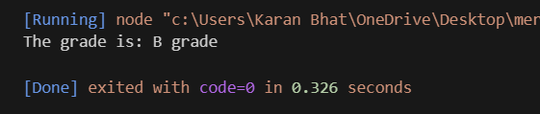

**Execution Steps:**

* Create a JavaScript file with any name
* Write the code
* And run the code in the terminal using F5 or right click and go to inspect and you can get the output in the console as well.